**ROTATING CUBE WIREFRAME**

**INTRODUCTION**

3D Cube Wireframe is a three Diamentional Wireframe (Transperent). The cube must be rotated with the friction factor of Y. It along the​ ax​is​ that passes through its center.

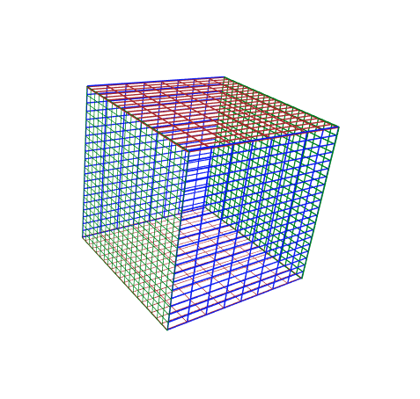

**DAY-1(29.06.2017)**

**APPROACHES:**

As I received my second project I started to do my project energetically, because purescipt was not a new language for me where my first project which was given by you paved the platform to learn some insights about purescript. I started my day by designing a cube. Initially I designed the single grid with grid I had converted it into a six phases cube. Later I have fixed the cube by defining the center of axis.

**CHALLENGES:**

* Suffered to bring the six phases of grids into the shape of cube (by which I came to know about how to have the control over the graphics and the corresponding dimensions).
* Faced some challenges when tried to fix the cube into its center of axis.

**DAY-2(30.06.2017)**

**APPROACHES:**

My second day started by fixing the cube in its standard position and planned to give the rotating effects to it and after applying the effect I am succeeded in accelerating the cube which can be done by swiping or dragging .To attain the acceleration I have used trackballcontrols function which is specially for purescript.

**CHALLENGES:**

* Faced some challenges when tried to fix the cube in its standard position.
* Faced some challenges when tried to specify the acceleration time in the trackballcontrols function.

**CURRENT STATUS:**

I successfully completed the task by accelerating the cube according to our JUSPAY requirement. Here the video for Rotation of 3D cube WireFrame done by Arunkumar Angappan @ juspay.

<https://youtu.be/8FlUb_j0D3Y>

**NOTE: I am interested to take up the METUTU project again which was not fully got shaped in my first project where I can complete it when I appear there for my internship.**